Embedded Linux on Small Form Factor PCB

Anh Doan   
*College of Science Cal State East Bay*  
Hayward CA, USAadoan2@horizon.csueastbay.eduYash Naik  
*College of Science*  
*Cal State East Bay*Hayward CA, USA  
ynaik@horizon.csueastbay.edu  
Eric Ramos *College of Science*  
*Cal State East Bay*HaywardCA,USA eramos@horizon.csueastbay.edu

# Introduction

A do-it-yourself Linux board has been a dream for many of us due to complex parts and the software to boot Linux. There are several solutions in the market in the form of Raspberry Pi, Arduino, or a Beaglebone board. Sure, the above-mentioned boards are very neat in their own way but they still are not a true do-it-yourself. The design files are not available and difficult hardware manufacturing process prohibits a new comer from designing a board similar to those off-the-shelf products. Off-the-shelf Linux boards help to skip certain steps in development phase but create new problems in exchange. Take the Raspberry Pi, if you wanted to increase the memory capacity or add another peripheral, well that is out of the question as all the parts are solder on without any space for addition. Finally, modules and boards always have shorter lifetime than the components they are made of. Off-the-shelf boards will become obsolete faster than certain types of CPUs, memory chips, peripherals etc. so designing our own custom board specifically targeting our own requirements will inevitably give more efficiency and better control in production.

# Block Diagram



This design is centered on an ARM9 processor made by Freescale (subsequently acquired by NXP). The processor is a SoC design that incorporates an onboard DDR memory controller and 4 built-in linear regulators. The design utilized a Linear regulator with a resistor divider Feedback loop to ensure the processor receives no transient voltage during its operation. The user code lives on the micro SD card that the processor will look at to boot up. The DDR memory module serves as the capacity in order to boot and run an OS like Linux. Interface is provided by a USB-A jack. JTAG and SJTAG pins are exposed in order to debug and monitor system operation using a serial console like Putty. Two MQ series sensors are installed to monitor the levels of toxic gases in the immediate environment. The sensors communicate via built-in ADC channels inside the i.mx processor.

# Schematics

Revision A

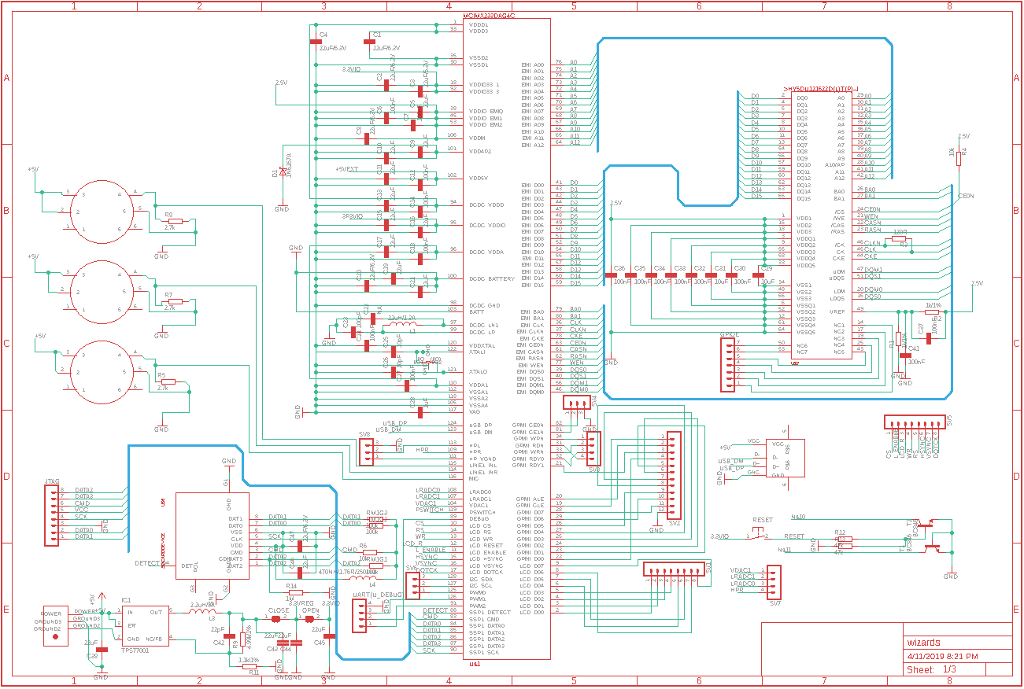

Revision B









Two primary devices on the schematic are the processor and the DDR memory module. The Processor has 128 pins and the memory module has 66 pins. The power circuit is made up of a DC-DC regulator and a Linear regulator for peripheral add-ons.

# layouts

Revision A



Our first Printed Circuit Board was a complicated since we did not have experience with the software. However, we were able to manage to learn the basics of the software and created our first layout in eagle. The first mistakes that we made in the layout was that we placed all the resistors and capacitors in the bottom left corner. Also, the crystal oscillator was not placed close to the processor. The capacitor and resistor should be located right next to the processor so that it can flow better. Resistors control the electric current as it passes through them and capacitor store electric charges. In addition, we decided to make the printed circuit board 5 in. by 5 in. since, it was very challenging to route all the wires around our 128 MCU and 66 pin Ram.

Revision B



In our second layout we fixed the mistakes we had made in revision A. The first mistake that we made was that our crystal was located far away from our microcontroller unit (MCU). Our crystal is a natural clock that was going to keep our printed circuit board working smoothly and on time. So, In Revision B, we tried to keep the crystal as close possible to the processor. Another crucial aspect we missed out in Revision A was that we did not add any LEDs onto our PCB which are essential for debugging purposes. So, In Revision B we have connected 3 LEDs; One is connected to the power rail to ensure current is flowing through the circuit and the other two are connected to the USB D+ and D-.

# (software section)

A Linux kernel must be built for our use. We used the following Linux distribution:

Distributor ID: Ubuntu  
Description: Ubuntu 16.04.3 LTS  
Release: 16.04  
Codename: xenial

All interaction during the build process is done through a Linux machine.

We made sure a cross compiler and git is installed:

$: sudo apt-get install gcc-arm-linux-gnueabi  
$: sudo apt-get install git

Download the Freescale bootlets, patches, and the elftousb2 utility:

$: git clone <https://github.com/koliqi/imx23-olinuxino>

Navigate to the directory of the downloaded kernel and download all sources:

$: cd imx23-olinuxino/kernel  
$: wget http://www.kernel.org/pub/linux/kernel/v3.0/linux-3.7.1.tar.bz2  
$: tar xvjf linux-3.7.1.tar.bz2  
$: mv linux-3.7.1 linux-stable

Apply the patches necessary:

$: cd linux-stable  
$: patch -p1 < ../0001-MXS-imx23-olinuxino-Add-i2c-support.patch  
$: patch -p1 < ../0001-ARM-imx23-olinuxino-Add-spi-support.patch  
$: patch -p1 < ../0001-rtl8192cu.patch

Configure the kernel:

$: make ARCH=arm CROSS_COMPILE=arm-linux-gnueabi- mxs_defconfig  
$: make ARCH=arm CROSS_COMPILE=arm-linux-gnueabi- menuconfig

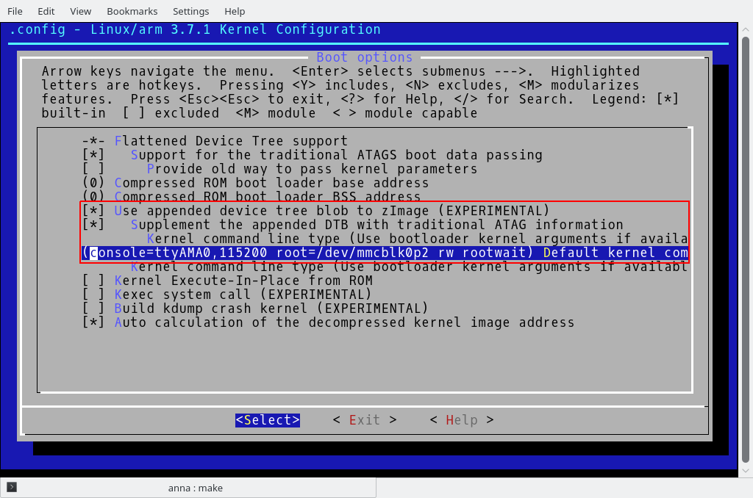

We checked the above options

We then enabled the driver for USB networking:

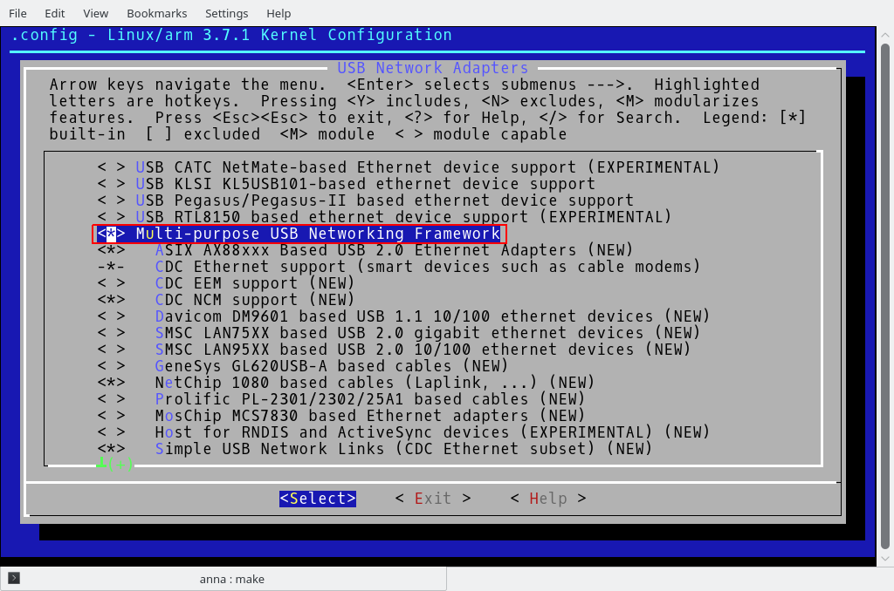

Enable IEEE 802.11 networking stack

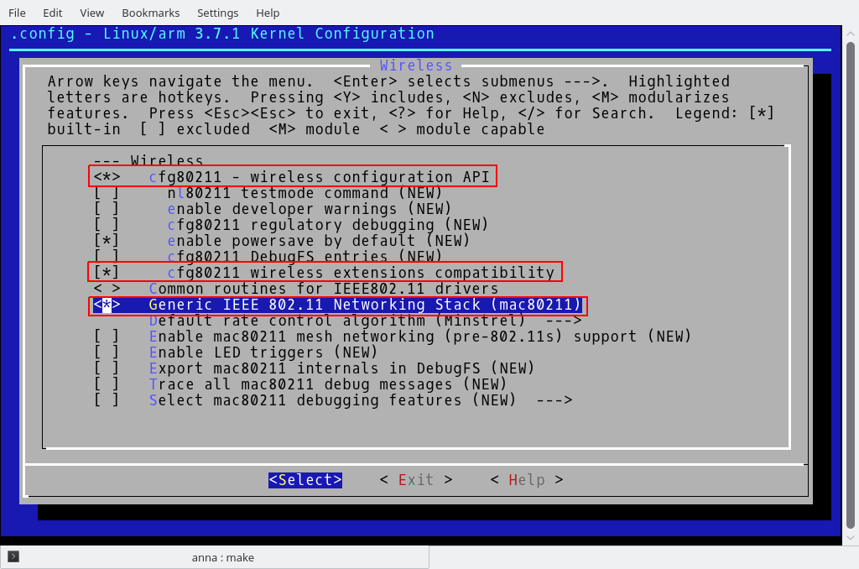

Activate Realtek 8192C USB WiFi and IEEE 802.11 for Host AP:

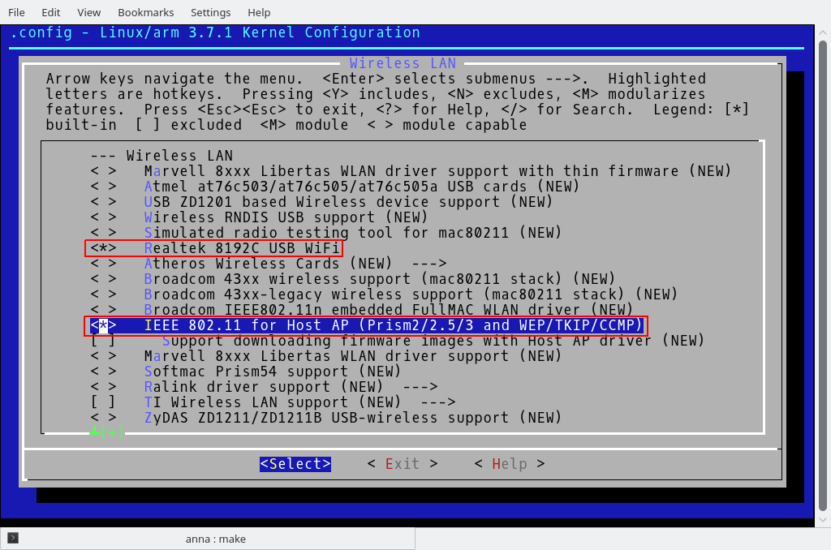

Finally, compile the kernel

$: make ARCH=arm CROSS_COMPILE=arm-linux-gnueabi- zImage modules

Create the device tree blob .dtb file:

$: make ARCH=arm CROSS_COMPILE=arm-linux-gnueabi- test.dtb

Join zImage and test.dtb:

$: cat arch/arm/boot/zImage arch/arm/boot/test.dtb > arch/arm/boot/zImage_dtb

The iMX23 SoC contains a built-in ROM firmware capable of loading and executing binary images in special format from different locations including MMC/SD card and NAND flash. Binary image is called a boot stream (.bs). Boot stream consists of a series of smaller bootable images (bootlets) such clock bootlet, power bootlet etc. Linking bootlets with kernel and converting from elf format to raw boot stream is done with utility elftobs.

We then untar the bootlets directory:

$: tar xvzf imx-bootlets-src-10.05.02.tar.gz

We apply the patches required:

$: patch -p1 < ../imx23_olinuxino_bootlets.patch

Finally, the bootstream file will be created:

$: make CROSS_COMPILE=arm-linux-gnueabi- clean  
$: make CROSS_COMPILE=arm-linux-gnueabi-

The linux kernel and the distribution was successfully installed and tested on a reference board that we had. Our mainboard was still going through hardware testing during this time.

# (milestone)

Initially we thought that our board did not boot up correctly when it only showed a 5 mA current draw. Speaking with the manufacturer, it was indicated that in non-initialized mode, the current consumption is expected to be around 6mA due to the fact that most SoC subsystems are still switched off and DRAM is not yet configured so the consumption is minimum. We went through many burnt processors thinking that our processor did not boot up because it was drawing too little current.

The next step was to show that the processor is indeed being recognized. We plugged in the USB cable to the board and ran a software called “BitBurner”. This software is made by NXP to do OTP (One-Time-Programming). We want to do an OTP because we want the processor’s bootloader to always look at the SD card location for the bootstream.

We achieved board boot up according to the manufacturer’s current consumption guideline. The next step is booting straight Linux.

# (reach goal)

Our reach goal would be to run the Industrial Smart Hazardous Sensor program that we wrote in our Microprocessor lab on the PCB. We have not attempted this reach goal as of this journal’s writing.